EDUCATION AND PRESENTERS CONFERENCE 2019
Conservation 2029 – Where Do
We Go From Here?

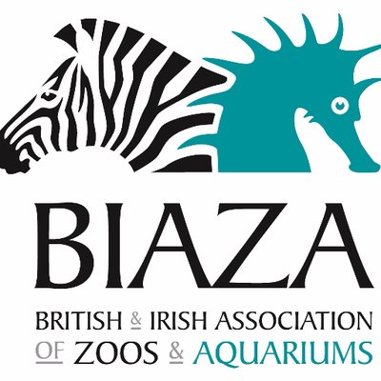

November 20th – 22nd 2019 at RZSS Edinburgh Zoo
Presentation Submission Form
Completed abstracts should be sent to education@rzss.org.uk by 30 August 2019
Submission Title
Presenter Name
Job Title
Organisation Name
Contact Email
Phone Number
Format of Submission | Short presentation - 5 mins
 | Longer presentation - 15 mins
 | Poster
Workshop - 90 mins
Maximum Number of Participants:

Any Specific Space Requirements:

Link to BIAZA Education Guidelines
[List the Category/Number of all guidelines most relevant to your submission. You can access the standards here]

To which of this years themes does your submission best fit?  (Can pick more than one) | Learning from the past  (e.g. Lessons learned)
Learning from others
(e.g. Partnership working and input from non-members)
Looking out with our walls
(e.g. Examples of outreach and inclusivity)
Making it count
(e.g. Effective evaluation and applying the BIAZA guidelines)
Reaching All Visitors
(e.g. Development of Interpretation and Effective Utilisation of Volunteers)
Predicting the future and telling the world
(e.g. innovative approaches, sharing good practice, publications, etc.)
Abstract

(Max 200 words)
Thank you for completing this submission form.
Completed abstracts should be sent to education@rzss.org.uk by 30 August 2019

OFFICE USE
Submission number:
Accepted/Rejected:
Agreed format:
Agreed session:
Additional notes:

