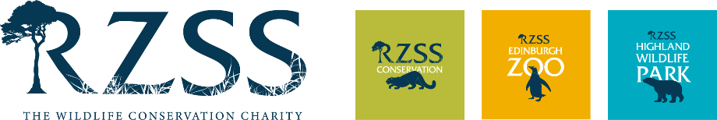

RZSS Holiday Programmes

Terms and Conditions

1 Sessions Dates/activities are subject to change due to the unpredictable nature of working in a zoo environment. Some activities are also weather dependent.
2 Groups Your child(ren) will be automatically placed into the school year group according to your booking form information. If input incorrectly, it is unlikely that your child(ren) will be able to move into the correct group.
3 Zoo rules Holiday programme children must obey the zoo rules that apply to all visitors: no feeding of the animals, no climbing safety barriers or entering staff only areas (unless permission is given and accompanied by a member of staff), no ball games (unless permission is given and accompanied by a member of staff), in the event of animal escape or fire to follow instructions given by zoo staff.
4 Supervision and behaviour You agree that your child will be under the supervision of Education Officers and that the child(ren) will respect and act upon the instructions of those staff and behave in an appropriate manner. We also expect parents/guardians to be polite and respectful to staff. Failing to do so would result in the child(ren) not being accepted onto (or removed from) the programme. Likewise, zoo staff will respond and behave in a professional and appropriate way.
5 Removal from the programme. In the unlikely event of consistent unruly behaviour and after two warnings have been given, children may be removed from the programme and no refund will be given.
6 Children must be collected at the end of the session by a parent/guardian. We will not release a child to anyone other than the parent/guardian unless you have informed us of alternative arrangements.
7 Health and Emergency information Upon receipt of a booking confirmation email from Eventbrite you must provide health and emergency information by following the link in the email. Failure to do so within the time limit provided may result in removal from the programme.
8 Cancellation policy Eventbrite operate the holiday programme booking process and they are unable to provide refunds.
9 Absence Please notify us as soon as possible (0131 314 0335) if your child is unable to attend any of the sessions they are booked on. No refund will be given for non-attendance.
10 Health (i) Depending on the severity of injury/illness, parents/carers will be contacted via phone call or informed at the end of the day. In the case of an emergency, you authorize the RZSS Head of Discovery and Learning (and zoo staff authorized by them) to give permission for any emergency medical treatment, including anaesthetic, as considered necessary by the medical authorities present, and for the zoo’s first aiders to administer first aid as appropriate.
11 Health (ii) You authorise designated staff to administer any medication your child is currently receiving.
12 Photography During holiday programmes we may take photographs and/or video footage which may be used for publicity or published by RZSS. There will be opportunity to sign an electronic form to give your consent.
13 Mobile phones Although children may bring mobile phones with them, we accept no responsibility for any damage or loss incurred. They should be set to silent.
14 Personal property We take no responsibility for valuables or other items your child brings with them. We strongly recommend they do not wear jewellery or bring valuable items such as tablets.
15 Food Children may not eat snacks outside of break times during holiday programmes unless linked to a health condition.
16 Toilet We expect children to be able to go to the toilet by themselves and ask when they need to go to the toilet. Staff will only assist a child in a toilet situation if absolutely necessary.
17 Staff The staff involved in holiday programmes will be checked by Disclosure Scotland and will become members of the PVG scheme. They will behave in an appropriate way when dealing with children and are subject to the normal disciplinary procedures for all staff at RZSS. Two staff members will be assigned to each group and other support staff/volunteers will be on hand.
18 Additional needs Our holiday programmes are open to all. We do not, however, have the resources to provide extra supervision and/or support for individuals with additional needs. A carer is permitted to accompany a child with additional support needs free of charge. Please contact us before booking if this is the case.
19 Complaints Should any issue arise that would cause you to complain this should be addressed to the RZSS Head of Discovery & Learning. If it is not dealt with to your satisfaction, then you may write to the RZSS Chief Executive.
20 Agreement In completing the Eventbrite booking process, you agree to all of the terms and conditions as described.

Please note that we reserve the right to vary the terms and conditions above, with prior notice.

